INTRODUCTION TO Engineering: AN INTERDISCIPLINARY COURSE at Federal University of ABC (ufabc)

Jesus F. A. Romero – jesus.romero@ufabc.edu.br
Patrícia T. Leite – patricia.leite@ufabc.edu.br
Gerson L. Mantovani – gerson.mantovani@ufabc.edu.br
Luiz S.Martins-Filho – luiz.martins@ufabc.edu.br
A. Lanfredi – alexandre.lanfredi@ufabc.edu.br
Universidade Federal do ABC - UFABC
Rua Santa Adélia, 166. Bairro Bangu.
CEP 09.210-170 – Santo André - SP - Brasil

Resumo: This paper describes the course "Introduction to Engineering" at Federal University of ABC - UFABC. The university offers a common basic course that every student of the university must accomplish. This course constitutes the BSc. on Science and Technology (BC&T), an intermediate graduation that can be followed by specific professionalizing courses to complete an engineering graduation. An elective course of BC&T, the "Introduction to Engineering", is offered to the students in order to introduce the basis of the engineering career, the engineering methods and thinking, and to present some professional ethical commitments, responsibilities and regulations. The course outline is composed by relevant topics to help the students to choose consciously their career, minimizing the classic problem of precocity in deciding the professional future. The adopted methodology includes activities concerning subjects proposed by the "Try Engineering" website portal, from IEEE organization, and the Brazilian engineering professional regulation councils (CREA/CONFEA). Lectures of invited professors introduces the specialties offered by UFABC, i.e., Aerospace Engineering, Bioengineering, Energy Engineering, Environmental & Urban Engineering, Information Engineering, Instrumentation & Automation and Robotics Engineering, Management Engineering and Materials Engineering. In this paper we report a general description of the proposed activities, the results obtained by the students groups, and our critical analysis of the methodology and its impacts on the following steps of the students embracing the career of engineering in UFABC.

Palavras-chave: engineering education; engineering methodology, CDIO method, TryEngineering Activities

introduction
The challenge presented in the engineering teaching in Brazil consists in new global scenery that intensive demands science knowledge and technology tools and requires professional highly qualified. The concept of professional qualification itself changes constantly specially with a larger presence of aspects related to the capacities of coordinating information, interact with people, and interpret dynamically the world social and environmental conditions (NAE, 2004). The new engineer should be able to propose solutions that are not just technically correct with innovation and creativity patterns, he should have the ambition of considering the problems in its totality, and insert itself in a causes and effects chain of multiple dimensions (SILVA, 1999). The incapacity to adapt our teaching approach to that scenery by trying to form professionals with such profile probably means a delay in the local and global development process.
Be part of a university establishment, with scientific and technological focus represents a huge opportunity and enormous responsibility of managing how to define, implement and transmit a modern engineer profile. In this sense, the teacher stuff main effort was devoted to the academic course project considering a suitable sequence and content in all disciplines. As this project was developed, several difficulties become evident, among them: the equilibrium issues needed between the different engineering courses contents and a common base course (BC&T) that all the students of the university must accomplish (UFABC, 2006). One part of the solution lies on some introductory disciplines offered by the engineering courses and that the post-BC&T students should attend. The content of the “Introduction to Engineering” discipline intends to train the abilities and capacities that modern engineer should have by means of different lectures, presentations, practice activities and, fundamentally, a social contact with the regional reality.
In section 2 the UFABC establishment process and the current institution context are described. In section 3 some curriculum project constrains related to the UFABC pedagogical project are presented. In section 4 some considerations related to the modern engineer profile are described. In section 5 the discipline “Introduction to Engineering” is presented as well as the main tools and methods used in the discipline project. The main conclusions of the work are presented in section 6.

THE UFABC CREATION PROCESS
In 2004 the Brazilian Education State Department (MEC) sent to the National Congress the law project that foresaw the creation of the Federal University of ABC (UFABC). In August of 2006 the first teachers stuff starts the initial lectures of the first 500 graduation students in the BSc. on Science and Technology (BC&T) determining the beginning of the university operation.
The Federal University of ABC developed its entire pedagogical project, including the courses, disciplines and statute considering the text "Subsidies for the Reform of the Superior Education", produced by the Brazilian Academy of Sciences (www.abc.org.br), and the "Bologna Declaration", produced by the European education Ministers.
The UFABC Academic Project considers the fast dynamic in science and technology fields, proposing an interdisciplinary matrix characterized by several areas intersection of scientific and technological knowledge. The Project emphasizes the importance of a scientific and integral technological formation, having as a goal the creation of a favorable academic environment to solutions development for regional and national problems (UFABC, 2006). Simultaneously, cooperation activities with other teaching and research institutions, as well as with several areas of the industrial sector were the main objective issues of the implantation process. In this sense, the fundamental idea of the university organization is the creation and maintenance of an interdisciplinary cooperation environment as widespread as possible. Thus, UFABC is not divided into departments, instead is organized associating the activities of teaching, research and extension around three great centers. They are: Center of Natural and Human Sciences (CCNH); Mathematics, Computation and Cognition Center (CMCC) and Engineering and Applied Social Sciences Center (CECS).
The Engineering and Applied Social Sciences Center (CECS) comprehends activities in the following engineering areas: Bio-engineering, Management Engineering, Aerospace, Environmental and Urban, Information, Material, Automation and Robotics, and Energy Engineering. Additionally, is included the area of Applied Social Sciences that has a complementary function in the students formation and acts like an interdisciplinary link with the engineering themes that involve social and economy issues.
It must point out that the UFABC engineering courses were established with base in the great lines of technological and strategic knowledge, necessary for all society development. These areas, of interdisciplinary character, do not follow the molds of traditional courses, demanding a great effort and focused comprehension of the professional profile to be graduated and of the chain of necessary knowledge for this process (CECS, 2008). This knowledge chain must to be reflected in the disciplines set to be offered, in order to be flexible, dynamic and to allow continuous updates. Thus, it is possible to guarantee consonance with a wished professional mobility and adherence to the pedagogical model established in the UFABC.

PLANNING CONSTRAINS
As a good design requires a master plan of how disciplinary content and learning outcomes will be integrated into the curriculum, several alternatives are possible. In any case, the learning of personal and interpersonal skills, and product, process and system building skills must be totally embedded in the engineering courses (CRAWLEY, E., 2008). Considering the UFABC pedagogical model, other several aspects should be taking into account by the engineering programs:
- Compatibility of the Post-BC&T engineering courses with BC&T considering potentially constrains related to the curriculum design. It must be noticed that, in order to guarantee an integrated program, the curriculum design is an explicit plan that must adopted and owned by the entire faculty (MORAES, 1999)
- Compatible contents with the suggestions and advices made by the Brazilian Regional Board of Engineering, Architecture and Agronomy (CREA) in order to guarantee professional attributions (MORAES, 1999)., (LONG W. P., 1998).
- Compatible contents with the norms regulated by the Brazilian “Education National Council” (CNE) and the Superior Education Commission (CES), (FERREIRA, 1999), (SALUM, 1999).
- Progressive scale of decisions taken by the students along the program in order to define their own professional preferences (LEITE, 2007). It must be pointed out that the UFABC student defines his engineering professional career close to the BC&T conclusion.
- Difficulty in monitoring and continuously update the contents offered by the different programs in the UFABC. It must be noted that after the BC&T course, beyond the eight engineering courses, the students can opt among eight bachelorship courses and five other degrees.
- Intense interdisciplinary not only with the basic knowledge areas, but among engineering several specialties.
- Students high autonomy on how to construct his own and personal curriculum. It must be considered that the BC&T curriculum is not strictly sequential (LEITE, 2007). Once prerequisites are inexistent in the case of UFABC, the connection among disciplines is determined by student choices.

CONSIDERATIONS RELATED TO THE NEW ENGINEER PROFILE
UFABC understands that the dialog between research and development depends on an enlargement of the social conscience about the importance of a shared growth among several sectors (NAE, 2004). According to ANPEI (National Association of Research, Development and Innovative Engineering), the Brazilian investment in R&D still is reduced when compared with other emerging economies (NARDI, 2001). In the other hand, some of the predominant industrial segments in ABC Region (São Paulo) - automobilist, chemist, mechanic and electronic - invested most in internal P&D activities in Brazil in 2002, according to the Brazilian Science and Technology State Department (MCT, 1993).
New experiences in Brazilian science and technology policies show that the creation of propitious environments aiming the interaction between public research sector and industry companies depends on proposals like technological parks, business incubators and innovation environments in private sectors (MCT, 1993). Furthermore, the communication with laboratories and technological centers of research in local, regional, national or international scope can conciliate actions of institutional policies integrating the scientific and social fields. In the other hand, some debates are pondering the education system and how can be managed in order to increase the future engineer possibilities in a globalized and avid world of technological innovations.
In a recent report (LEITE, P. T., 2007), the National Academy of Engineering of the United States, presents the future “2020 Engineer” main qualities. Among several attributes, the engineer should be:
- Creative and guided for innovation;
- A systems designer ;
- A collaborator;
- Disposed to embrace the cultural diversity.

In a report revision (ALMGREN, R. C., 2007), was verified that the complexity of the current innovations demands a great collaboration work between engineers, so is necessary to recognize that really innovative product requires the knowledge of many technologies. Thus, the future engineer, although can have profound knowledge of a technology, should be exposed to a vast area of other important knowledge. In conclusion, is observed that an interdisciplinary approach, emphatically fixed in the root of the UFABC pedagogical model (CECS, 2008), becomes essential for the future engineer when combined with a “problem solver” character.

Almgren in (ALMGREN, R. C., 2007) points out some engineering education aspects that must be considered in order to guarantee success in transferring the new engineering profile:

- Disciplines that integrate theory with practice activities.
- Challenging research projects offered as early as possible.
- Collaboration jobs in project activities.
- Exhibition for risks, challenges and uncertainties in order to stimulate the true creativity and innovation of the students.

All the above issues were considered in the proposal of the discipline "Introduction to Engineering", as described in section V.

“INTRODUCTION TO ENGINEERING” DISCIPLINE AT UFABC
In order to guarantee the Brazilian “Education National Council” (CNE) and Higher Education Commission (CES) norms, all engineering courses in UFABC presents an integrated curriculum with three main parts: introductory, disciplinary and specialization. Additionally, the main challenges of the engineering programs at UFABC, stated at the end of section III, are considered by the adjustment of some disciplines allocated in the final part of the BC&T course.

The disciplines set, that plays a key role in the engineering courses structure, is made up of the following form:

- Introduction to engineering (three months discipline)
- Experimental methods in engineering (three months discipline)
- Unified engineering I (three months discipline)
- Unified engineering II (three months discipline)

Where the three last disciplines consider activities eminently experimental and intensely interdisciplinary, using the BC&T main scientific and technological concepts.
The "Introduction to Engineering" discipline is an early engineering course that aims to define the scenario in which engineers work and, fundamentally, contributes to society. In this sense, the discipline project aims to stimulate and increase the student interest in the fields of engineering and, additionally provides the main engineering skills: personal and interpersonal, plus product, process, and system building skills. Table 1 presents the syllabus model considered at the UFABC “Introduction to Engineering” three-monthly discipline.
The introductory discipline “Introduction to Engineering” objectify train some essential skills, and provides a set of early authentic personal experiences that motivate the need for disciplinary content, and allow early fundamentals to be more deeply understood. The following sub-sections describe the main methods and tools considered in the discipline.

Table 1 - Syllabus considered on the UFABC “introduction to engineering” course (part I).
Day | Contents and/or Developed Activities
Day 1 | Program and activities chronogram presentation  Engineering structure offered in UFABC  Formation of working Groups  Activity 1: Synthesis on a text supplied by the teacher
Day 2 | Presentation of the “Try Engineering” (IEEE) program  Activity 2: Try Engineering class plan
Day 3 | Engineering: history and Development  The engineering in the Industrial Revolution
Day 4 | Introduction to the engineering project method  Activity 3: Constructing a glider
Day 5 | Proposal of the final project, groups discussion and orientation.
Day 6 | The Engineering concept: Solving problems  Engineering challenges in the contemporary society  Activity 4: Engineering Identification activities

Table 2 - Syllabus considered on the UFABC “introduction to engineering” course (part II).
Day | Contents and/or Developed Activities
Day 7 | Activity 5: Project Work Day
Day 8 | Engineering lectures in UFABC - Information Engineering, Aerospace Engineering, Bio-engineering and Management Engineering.
Day 9 | Engineering lectures in UFABC - Instrumentation engineering, Material Engineering, Energy Engineering and Environmental Engineering  Activity 6: Questionnaire about engineering
Day 10 | The Science and Technology in local Development  Decisive factors for the technological development  The computer era: Micro-electronics
Day 11 | Ethical in the engineering; Interaction rules  Ethical engineers; Resources allocation
Day 12 | Meeting to verify the organization of the final project
Day 13 | Final activity: Engineering project and Technological Innovation  Presentation of the final activity  Exposition of the projects  Activity 7: Participation in the exhibition

CDIO Approach
As the CDIO method suggest, the introductory discipline we deal includes several design-implement experiences carried out by student teams of four to six members. As table I presents, the design-implement experiences tend to account for at least 50% of the total time devoted to the course. The projects focus on different stages of product or process development. All teams consider every phase of development, from conceiving through operating (WEST, H., 1991). Students are able to demonstrate an understand how to design and build a devices from an unidentified assortment of parts (NEWMAN D. J., 1991). The activities developed in the discipline verify that the students became motivated with the opportunity of develop their own ideas in a project.
Starting from the requirement specification, the first step in the project work is to create a project time plan. During the project groups have regular meetings, and they present all project results to the instructor according to the requirement specification defined by the problem analysis. In the last part of the discipline each group writes a reflection document in which they evaluate their work, both in terms of technical results and team work.
As the modern engineers are involved in all phases of a product, process, or system lifecycle, the discipline “Introduction to Engineering” aims to contribute in a complete formation of the engineers. This emphasis on the product or system lifecycle (Conceive-Design- Implement-Operate) defines the context for engineering education and not the content (CRAWLEY, 2008).

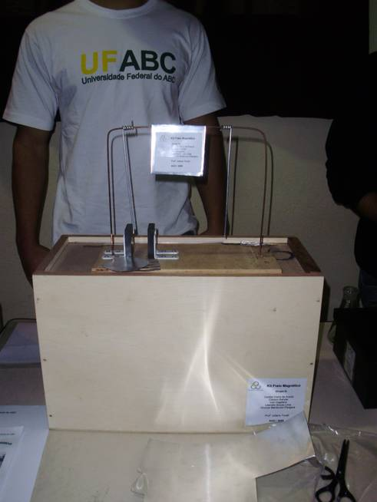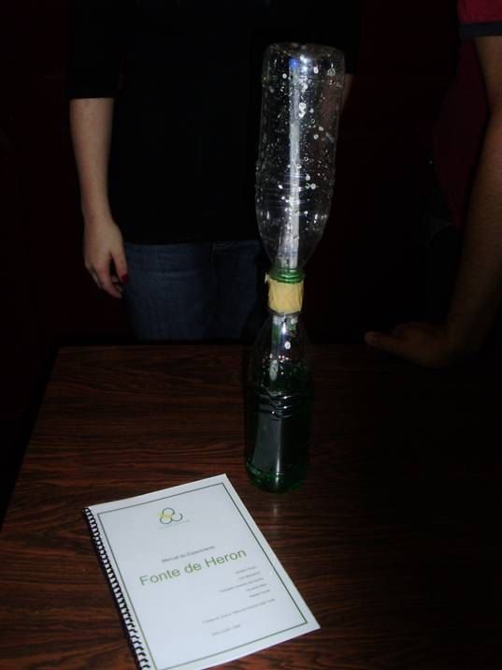
Figure 1. Eletromagnetism and Fluid Mechanics experiment implementations
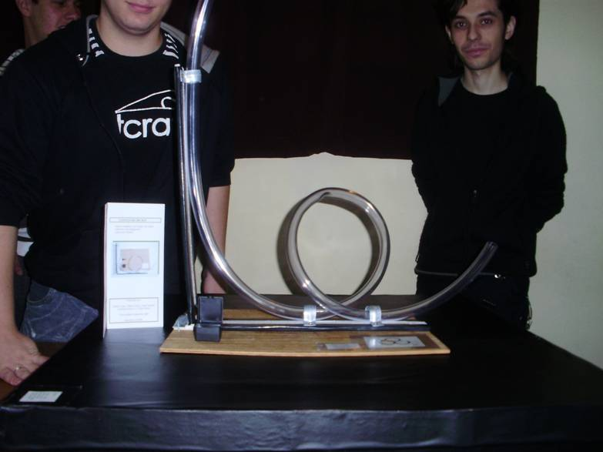
Figure 2. Dinamic Systems experiment implementation

Try Engineering Approach
The Try Engineering organization offers information about engineering careers including games, lesson plans, information about engineering programs at universities, profiles of engineers and other data posted by volunteers. The organization site (www.tryengineering.org) constitutes a great resource of examples and activities for the engineering students. One of the main motivations in using the TryEngineering approach in the discipline “Introduction to Engineering”, consist in establish a suitable and complementary link with the project “Engineering in High Schools” financed by the Brazilian Projects and Studies Founding (FINEP) and proposed by the discipline supervisors. One of the main objectives of this project is promote the engineering profession in public high schools by joining the UFABC and high school students in order to facilitate experiences sharing. It is feasible, by means of some interaction with the students engineering activities, to promote vocations and to recruit more prepared students for the technological areas. With this goal in mind, all the implementations of the student activities were donated to the “State Technical School Júlio de Mesquita” located in Santo André -SP. Figures 1-6 shows some of the implementations built according the CDIO concept by the UFABC students and figure 7 presents the moment when the high school students were receiving an explanation about the donated material.

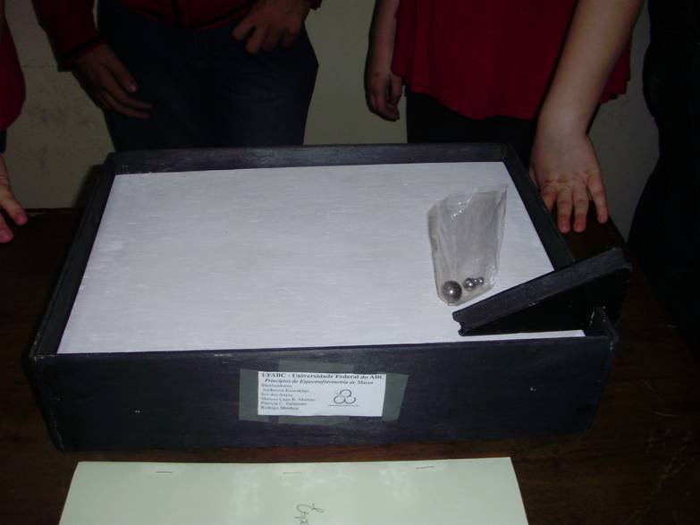
Figure 3. Friction experiment implementation
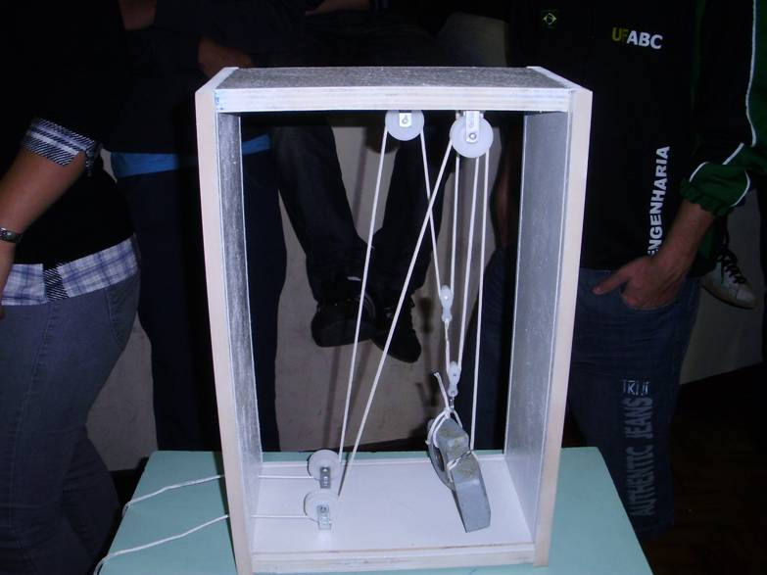
Figure 4. Pulley sistem experiment implementation
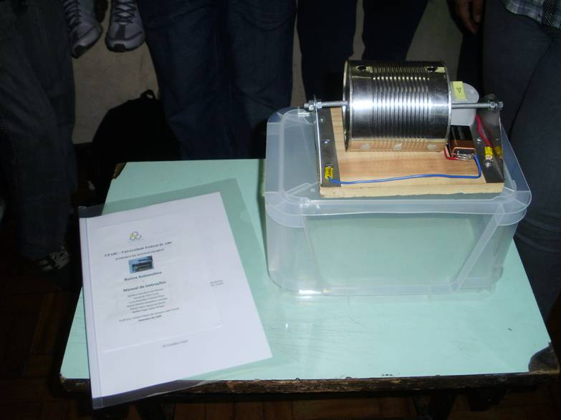
Figure 5. Telephone principles experiment implementation

The UFABC IEEE Student Branch
The partnership between the discipline supervisors and the UFABC IEEE Student Branch favor the participation of several guest teachers of different engineering areas in a series of seminars related to the different engineering courses in UFABC. Additionally the IEEE branch students could participate in the “Introduction to Engineering” course announcing the main activities that the branch develops inside and outside the university, and inviting the students to take part in the group by disclosing several activities and projects.

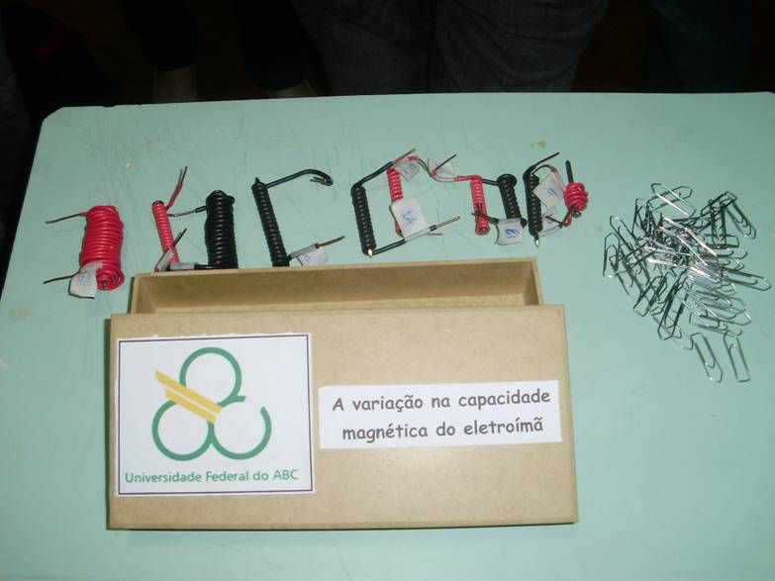
Figure 6. Magnetic Capacity experiment implementation
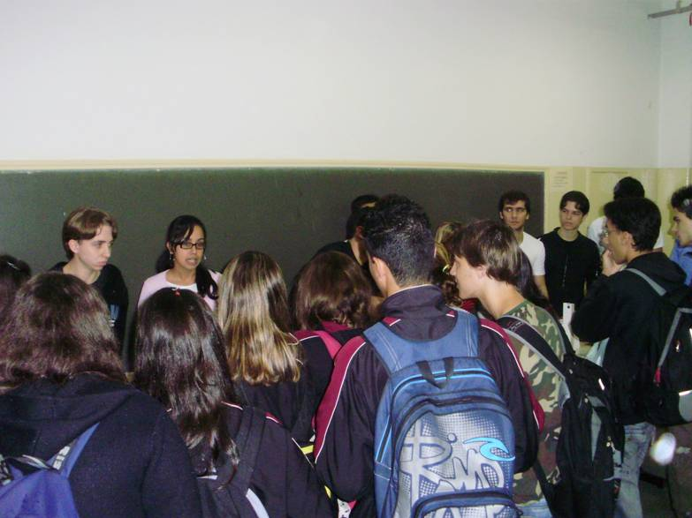
Figure 7. High school students receiving an explanation about the donated experiments

CONCLUSION
The present work describes how the discipline "Introduction to Engineering" is inserted in the curriculum design process of all engineering courses at the Federal University of ABC. Although the university is still in implantation, fact that presents the opportunity of construct an integrated academic curriculum in agreement to modern methods and strategies, are also exposed some particularities of the university pedagogical project that should be considered.
Application of the syllabus, developed for the course "Introduction to the Engineering", showed clearly two main results: a) A contribution to maintain an integrated curriculum where all students develop interpersonal skills, and product, process, and system building skills through CDIO concepts and activities suggested in the "TryEngineering" site; b) A contribution to the concern about the society needs of engineers and technical professionals for the new global challenges. With this goal in mind, all the student implementations were donated to a local State Technical School.
Future activities will consider a more insight interpretation of engineering introduction disciplines in early stages of the BC&T curriculum and the possibility of a curriculum based on disciplinary prerequisites. Noting that, the outcomes of a study program are difficult to be predicted from the intentions of the program or by the decisions made by the students.

Acknowledgments
The authors thank the Federal University of ABC (UFABC) and all the stuff involved in the project of the “Introduction to Engineering” discipline. The authors thank the Brazilian Projects and Studies Founding (FINEP) for the founding support for the project “MCT/FINEP/FNDCT – PROMOVE – Engineering in High Schools”.

REFERENCES
NATIONAL ACADEMY OF ENGINEERING (NAE), The Engineer of 2020: Visions of Engineering in the New Century, The National Academies Press, 2004
SILVA, D. “The engineer who the companies want today”, Curricular tendencies and matters of Florianópolis technological organization, UFSC Press, 1999.
UFABC, Pedagogical Project of the Federal University of ABC – UFABC, Santo André – SP, Brazil, February, 2006
ENGINEERING AND APPLIED SOCIAL SCINECES (CECS) Direction, UFABC Engineering – CECS Basic Project, Santo André – SP, Brazil, February, 2008
CRAWLEY, E. MALMQUIST, J. OSTLUND S. AND BRODEUR D., Rethinking engineering education, the CDIO approach, Springer, 2008
MORAES, M. C. “The engineer's new times profile and the new educational agenda”, Curricular tendencies and matters of Florianópolis technological organization, UFSC Press, 1999.
LONG W. P. and. TELLES da C M. O., “Engineering development Programs: Current situation”, Engineering Teaching Magazine, 1998.
FERREIRA, R. S. “Curricular tendencies in the 2000 engineer's year”, Curricular tendencies and matters of Florianópolis technological organization, UFSC Press 1999.
SALUM, M. J. G. “The engineering curriculums in Brazil – current stage and tendencies”, curricular tendencies and matters of Florianópolis technological organization, UFSC Press, 1999.
LEITE, P. T., DOS SANTOS,. R. C., WALDMAN H., “Innovation in Engineering Teaching”, Seminário Nacional de Produção e Transmissão de Energia Elétrica, Rio de Janeiro, Outubro de 2007
NATIONAL ACADEMY OF ENGINEERING (NAE), The Engineer of 2020: Visions of Engineering in the New Century, 2004, National Academic Press.
NATIONAL ASSOCIATION OF RESEARCH, DEVELOPMENT AND INNOVATIVE ENGINEERING (NARDI), Industrial indicators of Technological Innovation, MCT Press, 2001
BRAZILIAN SCIENCE AND TECHNOLOGY STATE DEPARTMENT - MCT, Brazilian industry Competitiveness study, MCT Press, Campinas, 1993.
ALMGREN, R. C., “Converging Complexity Challenges Educators to Prepare Tomorrow’s Innovators”, Photonics Spectra, january. 2007
WEST, H. “A Criticism of an Undergraduate Design Curriculum”, Design Theory & Methodology, ASME DE, Vol. 31, 1991, pp. 7-12.
NEWMAN D. J., AMIR, A. R. “Innovative First-Year Aerospace Design Course at MIT”, Journal of Engineering Education, Vol. 90, No. 3, 2001, pp. 375-381.

